

**Contents**

**Group Response to Comments from Phase 2 3**

**Phase 1 |** Project Selection

**1.0 Project Description 4**

**2.0 Identifying the Business Problem 4**

**3.0 Available Data 4**

1. Number of Instances 4
2. Number of Features 4
3. Missing Values 4

**4.0 Target Variable 4**

**Phase 2 |** Data Understanding and Data Cleaning

**5.0 Exploratory Data Analysis 6**

1. Random Sampling 6
2. Data Cleaning 6
3. Frequency of the Target variable 7
4. Attribute Analysis / Preliminary Visualizations 7
5. Missing Values & Duplicates 7
6. Relationship between Variables 8
   1. *Weights of Information Gain 8*
   2. *Correlation Matrix 8*
7. Possible Outliers / Removed Attributes 9

**6.0 Baseline Model Building and Evaluation**  **9**

1. Multiple Algorithms 10
2. Baseline Optimization 11
3. Model Building (Creating Baseline Model) 11
4. *Accuracy, Precision, Recall, & f-measure (benchmark) 11*
5. Feature Selection 12
6. Feature Engineering 12
7. Parameter Optimization 12
8. Ensembles 12
9. Initial Evaluations (Baseline w. Improvements) 12

**7.0 Model Modifications and Improvements**  **14**

1. Via Baseline + Filtering Missing Values (Dept. Time Military) 14
2. Via Baseline + Filtering MV + Distance 14
3. Via Baseline + Filter MV + Distance + One-Hot Encoding (Day) 14
4. Best of the Best 15
5. Via Baseline + AdaBoost (with Vote of (6) GBT) 15

**Phase 3 |** Results & Business Strategy

**8.0 Results and Observations 17**

**9.0 Solving the Business Problem 17**

1. Procedure (Formulating the Business Strategy) 17
2. *Market audit to verify consistency 18*
3. *Value-Chain Analysis 18*
4. *Identify Main Thrusts 18*
5. *Moving Forward 19*
6. Description 19
7. Insights & Recommendations 19
8. Closing Thoughts 21

**References 22**

**Appendices 23**

Appendix A – Data Dictionary 23

Appendix B – Weights by Information Gain 24

Appendix C – Correlation of Attributes 26

**Group Response** to Comments From Phase 2

**A Message to the Reviewer:**

**

*Prof. Castellanos,*

*Please find the table below, addressing your comments*

*made to the Phase 2 portion of our group project.*

*Thanks.*

**

*Group 2*

|  |  |  |  |
| --- | --- | --- | --- |
| **Location**  **(within this report)** | **Remark / Comment** | **Our Response** | **Action** |
| Pg. 4 – Phase 1 general | “Excellent introduction!” | “Thanks!” | *No changes.* |
| Pg. 7 – Figure 3 | Is this representative of the original dataset? [~40% of flights are delayed]  _________________________________________________  Not for this project, but it would be interesting to see if this ratio varies in different months. | “Yes”  __________ | *No changes.*  __________ |
| Pg. 7 – Figure 4 | “Very interesting! Good insight.” | “Thanks!” | *No changes.* |
| Pg. 7 – Figure 5 | “Good insight too.” | “Thanks!” | *No changes.* |
| Pg. 7 – § 5.f.*i* | “Note that info gain is one method. Another approach would be to try different variable importance methods and see which ones are consistently relevant/irrelevant.” | “Addressed in the correlation matrix.” | Added clarifying language in § 5. |
| Pg. 12 - § 6.d | “If I recall correctly from our conversation last time, the DEP_TIME reflects the actual departure time whereas the DEP_TIME_BLK reflects the block of the 'scheduled' time, potentially leaking the 'delay'. **Include the variable importance weights to see if it is highly associated to the target variable.** Make sure you include this for the final deliverable.” | “Specified that twice in § 5 & § 6. Fig. A-1 in A-A and A- C answers. comment.” | Added clarifying language  in § 5.g and addl. Figs. in § 5.e. Added A-C. |
| Appendix – Figure A-3 | ” Make a table with the top variables and assess whether it is a valid attribute to use and not one that leaks info about the outcome (i.e., delay)” | “Addressed and added figs. + lang.” | Added addt’l fig.in appendix B. |
| ~ Pg. 21 – Figures A-5 & A-6 | “Explain these graphs. What is the insight coming out of this? There is no reference of these figures in the report.” | “It is easier to remove since these figures are outdated. Relocated to § 6.a to show progress” | Both graphs removed / relocated and appendix figure references revised. |

Phase 1 Project Selection

**1.0 Project Description**

Our team’s project will collect and analyze data pertaining to the airline flight timeliness of all domestic airline flights in the United States, via sampling one arbitrary month in 2019, to determine the ratio of flights that are on-time versus flights that are either delayed or cancelled. Microsoft Excel, Tableau 2019.2, and RapidMiner Studio 9.3 will be utilized throughout various aspects of the knowledge discovery in database (KDD) process.

**2.0 Identifying the Business Problem**

On any given month, airports throughout the United States handle upwards of over 500,000 domestic flights. Airline competition is oligopolist and fierce, with airports struggling to meet demand and investing heavily in necessary infrastructural improvements to operate at peak efficiency. Therefore, it is imperative to be able to track, and possibly predict, the reliability of flights, dependent on factors such as origin, destination, airline carrier, and so on. This information can be used to identify potential weakness, either with an airport, airline carrier, or both, and open avenues for improvement.

**3.0 Available Data**

Our data has been obtained through a data portal available via the U.S. Bureau of Transportation Statistics (BTS) website (<https://www.transtats.bts.gov>). The benefits of utilizing this data source are threefold: (1) the data is being obtained from a reliable source, a federal agency, (2) our group has the ability to control the number of attributes via the data portal, and (3) our group has the ability to sample from any calendar month ranging from 1987 to as recent as September 2019.

1. Number of Instances

Our June 2019 Microsoft Excel comma separated value (.csv) file currently contains 636,692 instances. Our group believes instances will decrease via data preprocessing and data cleaning.

1. Number of Features

Currently, the number of activated features is at 64. However, our group has the flexibility to choose how many features we wish to activate via the BTS data portal, before downloading the .csv file. Furthermore, using the “Select Attributes” operator via RapidMiner will greatly hone into the attributes our group will concentrate on.

1. Missing Values

The dataset is mostly intact and complete, with missing values in only a few columns. A potential issue we thought we needed to address was to standardize time zones and ensure all timestamp columns were converted to GMT / Zulu time to ensure the data is conformed across date time dimensions. However, after further analysis, we realized this did not hinder our data optimization process.

**4.0 Target Variable**

There is flexibility in defining our target variable, depending on our group’s choice of supervised learning: classification or regression. In regression, the target variable will likely be DEP_DELAY, which represents a flight’s departure delay minutes. Additionally, we would need to create a Boolean binary On-Time / Delay Indicator column, where if there was a delay (Actual Dep. Time – Sched. Dep. Time > 0, then 1), and if the flight was on-time (Actual Dep. Time – Sched Dep. Time ≤ 0, then 0). For classification, this On-Time / Delay Indicator would be our target variable. **However, our group will be focusing mainly on classification.**

To accomplish the task of the On-Time / Delay Indicator, a new column was created adjacent to the delay attributes, whereby an IF statement calculated that if the attribute DEP_DELAY, the amount of minutes a flight is delayed beyond a scheduled departure time (counterintuitively negative signifies early, positive signifies late), the following relationship holds: IF (DEP_DELAY > 0, 1, 0). This allows our group a clear binary response to whether a flight was delayed or on-time. Part c of Section 5.0 – Exploratory Data Analysis examines the frequency of the outcome of this new target variable, labeled DEL_TARGET.

Phase 2 Data Understanding & Cleaning

**5.0 Exploratory Data Analysis**

Through the exploratory data analysis process, it was vital for our group to perform a random sample on the original 636,692 instances, as running any type of data analysis, whether via Excel or RapidMiner, would be too tedious, inefficient, and cumbersome to run with the original data. Afterwards, the frequency of the target variable and consequent relationship between variables can become attainable, whereby data visualizations can be generated.

1. Random Sampling (@ 10%)

Originally, a random sample was generated by first filtering out all canceled and diverted flights from the data, then deleting two specific columns, CANCELLED and DIVERTED respectively, from the original dataset. These two variables were attributed to, if not but all, instances of missing variables. Afterwards, a new column in Excel in Column A was created to use the RAND function, generating values between 0 and 1 for all 600,000+ instances. Then, all RAND values were sorted numerically, whereby 10% of the data was sampled, starting from the highest RAND values to roughly 10% of the remaining values, resulting in a random sample of 62,088.

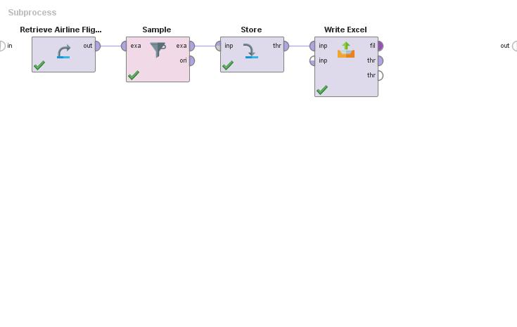To minimize uncertainty and tampering of the original data, this process was mimicked through RapidMiner, with only the target variable column added manually via Excel.

**Figure 1:** RapidMiner screenshot of original random sampling.

This was also done to maintain data consistency and integrity while engaging in groupwork. However, what our group noticed was that via spot-running of quick-and-random models, performance vector figures hovered near 100%, signifying the data may be imbalanced or skewed, foreseeing a need to possibly boost the minority class to hinder bias.

1. 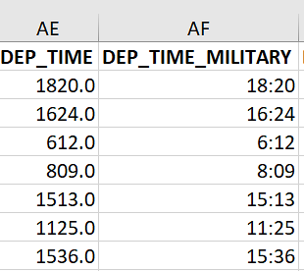Data Cleaning

Excel was used to convert the DEP_TIME variable from an integer to military time, using the formula TIMEVALUE (REPLACE (DEP_TIME, LEN(DEP_TIME) -1,0,”:”)) *[Fig. 2]*. RapidMiner processed this data in the form of an integer, consequentially leading to a bias and answer leakage in our f-measure. For RapidMiner to perform a time-series analysis on our data set, it was vital to convert time from integer to military time.

**Figure 2:** Excel snapshot of time-series conversion.

1. 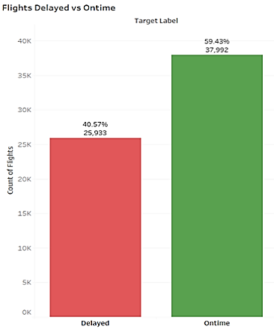Frequency of the Target Variable

Via both Excel and Tableau, *Fig. 3* illustrates that approximately 41% (25,933) of sample data flights, representative of the original data set, are delayed, with roughly 60% (37,992) of sample data flights reporting an on-time status. As this 60 / 40 relationship re-appeared no matter our way of sampling, nor how many times we have re-sampled, the data for June 2019, our team can safely assume that the sample set can proxy for June 2019 that only 60% of all domestic flights were on-time!

**Figure 3:** Tableau screenshot of bar graph for target variable frequency.

1. 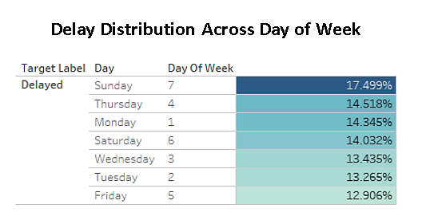Attribute Analysis / Preliminary Visualizations

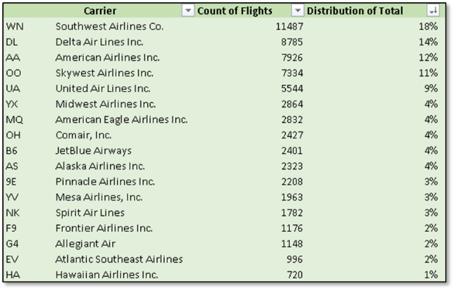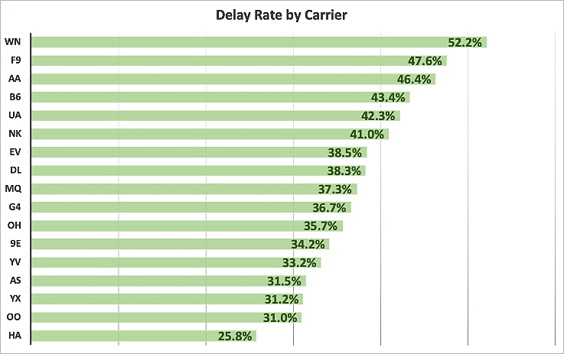Tableau was ideal in further examining certain characteristics of key variables, providing insightful visualizations. For example, a striking find was that most delays occurred on Sunday, approximately 17.5% of the time *[Fig. 4]*, with Southwest Airlines Co. (WN) performing the worst, at approximately 52.2% *[Fig. 5]*. This complements with *Fig. 6* in that Southwest Airlines also has the highest number of flight distributions, at about 18% of the sample total.

**Figure 4:** Delay Distribution by Day of Week

**Figure 6:** Delay Distribution w/ no. of flights.

**Figure 5:** Delay Distribution by Carrier

1. Missing Variables & Duplicates

When the original data was uploaded onto RapidMiner, the program detected no duplicates. Upon observation, there were missing variables attributed mainly to the CANCELLED and DIVERTED attributes respectively. This makes logical sense as there would be no flight information for a cancelled flight, and information for a diverted flight would be inaccurate as the destination has been altered, possibly due to any number of issues before or during the flight. A process was also run via Excel to count missing variables per association with attribute, which revealed the attributes TOTAL_ADD_GTIME, LONGEST_ADD_GTIME, FIRST_DEP_TIME, and CANCELLATION_CODE had 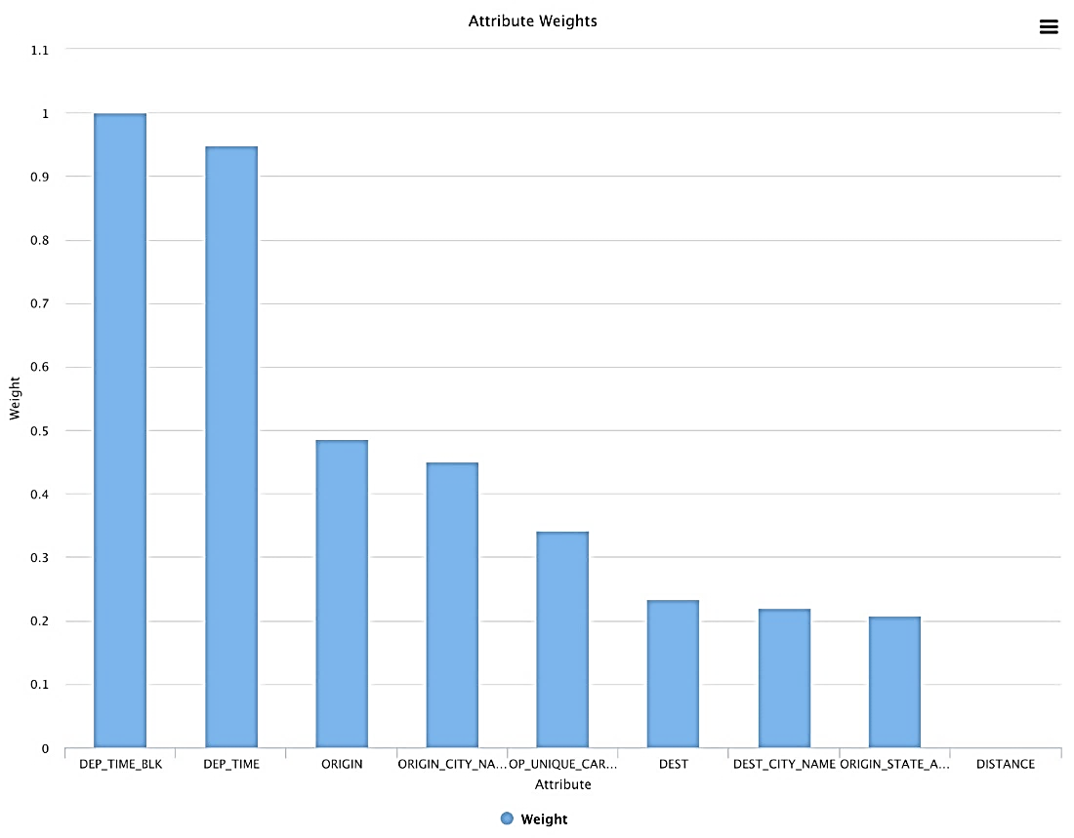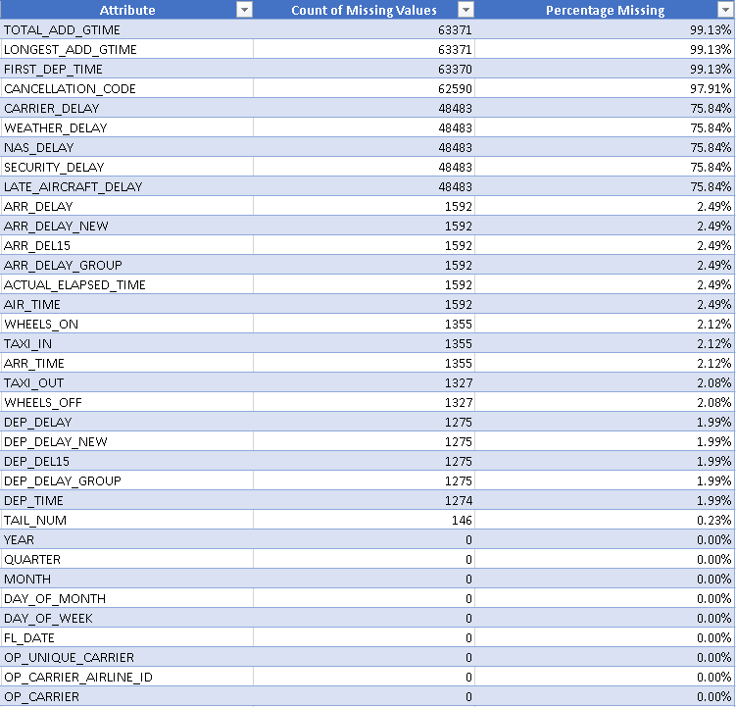the highest counts of missing values *[Fig. 7]* at above 95%.

**Fig. 7:** Attributes with missing variables count.

**Fig. 8:** Attributes w/ highest weight.

1. Relationship between Variables

An important step in the data understanding process is determining the weights of the variables and the collinearity between them. In total, 57 attributes were removed, resulting with the correlation matrix, *Fig. 10.*

* + 1. 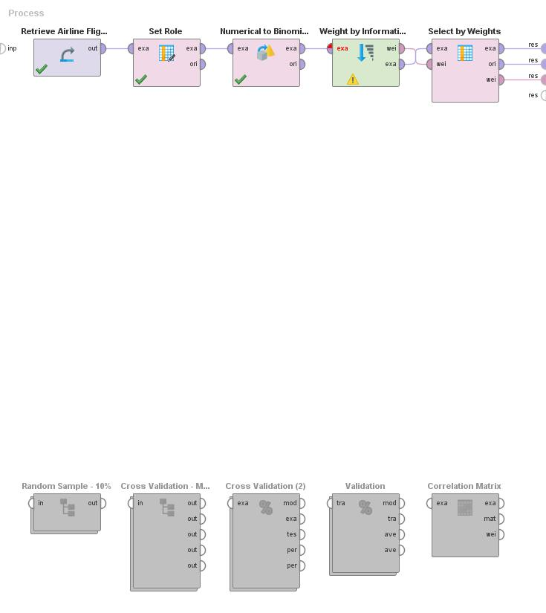*Weights by Information Gain*

**Figure 9:** RapidMiner screenshot for run of Weight of Information Gain.

Use of the “Weight of Information Gain” operator revealed some attributes that did not carry any weight, where a threshold of 0.005 was used to determine if these attributes could be counted. With the weight standardized, and by observation, 31 attributes had an information gain of less than .005, signifying at least 31 attributes would be disregarded. *Figure 9* portrays the process and *Figure 10* displays the output. However, our group believes DISTANCE might carry some other necessary information, so we decided to keep it in some iterations of our model building. Appendix B and *Fig. A-1* show weights of important variables and cut-off to importance.

* + 1. *Correlation Matrix*

Our group ran the “Correlation Matrix” operator to observe possible correlations among the attributes, discovering some attributes are highly correlated to each other, signifying the delivery of similar information.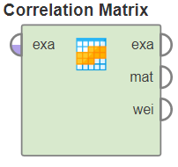 Attributes not disregarded by the weights of their information gain was run via the “Correlation Matrix” operator, to visualize possible correlational relationships between 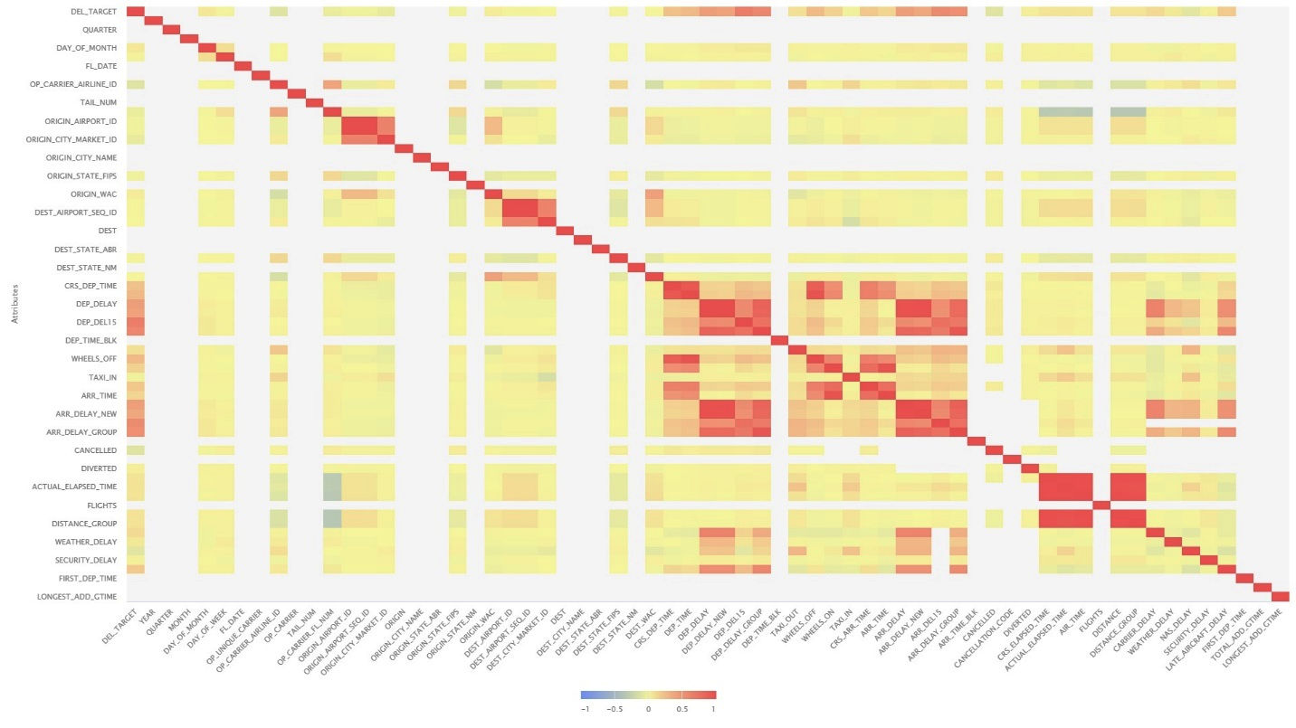important variables. *Fig. 10* illustrates the correlation matrix as a heatmap. Please also refer to Appendix C for correlation of attributes.

**Figure 10:** Correlation matrix heatmap for weight by information gain.

1. Possible Outliers / Removed Attributes

As our group has the ability to choose how many and how few attributes to download from the BTS’s website, by observation, any attributes that were nearly blanked were automatically omitted and removed. There may be outliers in our data, which becomes more apparent via the data visualization portion of the project.

For removed attributes, originally, we had peculiar results where our performance vectors where at or near 100% *{Fig. 12]*, with lift exceeding 100%. This situation can be indicative of a bias, strong weight of the majority class, or target variable leakage. Upon troubleshooting the problem, it was found that both DEP_TIME and DEP_TIME_BLK were leaking the solution to our model within the “Select Attributes” operator, therefore skewing our results and leading to an artificial bias. Once both of these variables were deselected, f-measures hovered around 50% (baseline).

**6.0 Baseline Model Building and Evaluation**

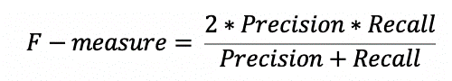Our team began with the model building and evaluation process by first selecting the type of predictive model we wanted to use, in order to create a baseline that can be later used for benchmarking purposes. Since the target attribute is currently represented as numerical values of 0’s and 1’s, we used the “Numerical to Binominal” operator to ensure RapidMiner can interpret the target attribute as binominal values (Boolean: True or False). Next, we used the “Set Role” operator to declare the target as our class label. Our goal is to build a classification model that has the highest f-measure while predicting whether a flight would be delayed or not. f-measure is defined as follows:

While maximizing both precision and recall is important, we will focus on producing the model that has the highest f-measure. We will be building several models and compare their f-measures to choose the one that is the most accurate on the training set before applying our predictive model to the scoring dataset.

1. Multiple Algorithms

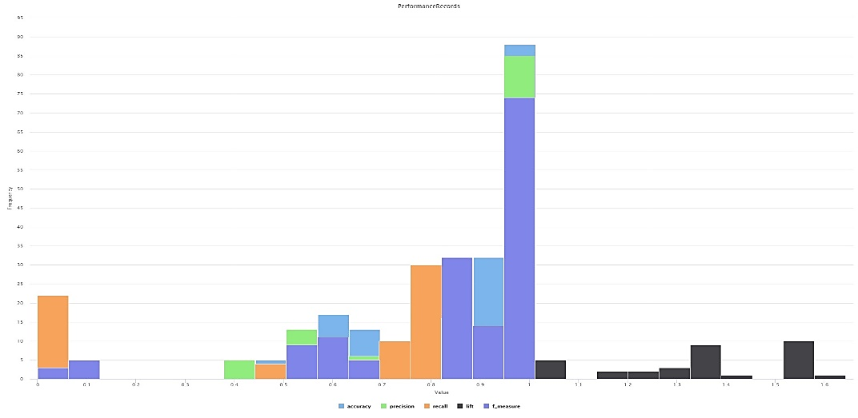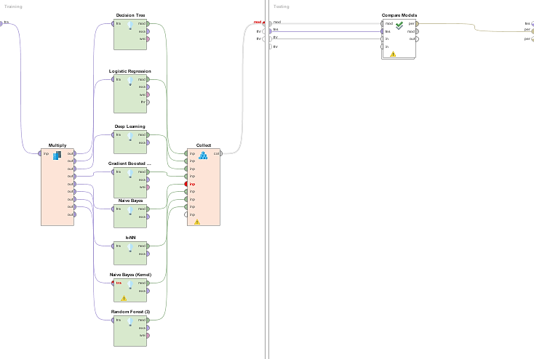With “Set Role” programmed to the DEL_TARGET variable, “Select Attributes” set to the attributes selected in Section 5.0 part e, and the use of one-hot encoding “Nominal to Numerical” operator (with attributes DEST, OP_UNIQUE_CARRIER, and ORIGIN selected), in order to boost prediction, an overnight run was performed on a 5-fold cross-validation, with a Compare Models run against the following models: Decision Tree, Deep Learning, Gradient Boosted Trees, Logistic Regression, Naïve Bayes, Naïve Bayes (Kernel), k-NN, and Random Forest. *Figures 11 & 12* shows the RapidMiner 5-fold cross-validation process and resulting skewness. What became prominently apparent was processing speed severely diminished when running multiple algorithms / operators simultaneously.

**Figure 11:** First attempt running 8 models within a 5-fold cross-validation.

**Figure 12:** Graph of target variable leakage and skewness towards 100%.

1. Baseline Optimization

Our group has attempted various optimization features in order to increase the performance of recall and our F1 score.

The following 7 features attempted have failed in model running:

* SMOTE (synthetic minority over-sampling technique). Upon research, we realized this operator is not suitable because our data is relatively balanced. SMOTE is better used when there is a bigger gap between the minority and the majority classes (e.g.:97% majority vs 3% minority).
* SVM (support vector machines): all variations
* PCA (principal component analysis): all variations. Although PCA ran, model runtimes increased substantially while not providing meaningful results.

*The next four are visualization operators:*

* Clustering, except for Random Clustering
* Compare ROCs
* Visualize Model by SOM
* Lift Chart

Other optimization methods include parameter optimization, explored in *part f*, and ensemble operators, found in *part g*.

1. Model Building (Creating Baseline Model)

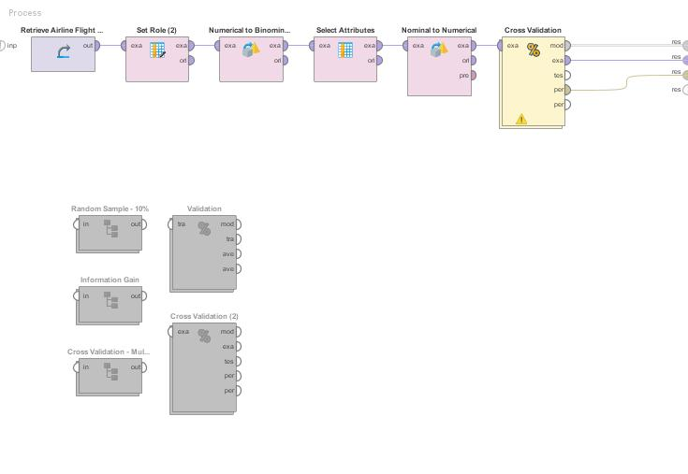This is arguably the most difficult, yet one of the most vital, steps in the model building process. This process quasi-hinders on knowledge and some trial-and-error. Initial preliminary models, with a simple 5-fold cross-validation using any machine learning (ML) operator, such as Deep Learning (DL) and no attributes select can produce artificially-high measures (e.g. accuracy, precision, etc.) to as high was 99%, suggesting overfitting. Whereas, extremely low figures (i.e. 1%) indicates possibly a processing error. After many false starts, *Fig. 13* proved a promising first step.

**Figure 13:** RapidMiner screenshot of baseline model.

* + 1. *Accuracy, Precision, Recall, & f-measure (benchmark)*

The model *[Fig. 13]* produced the following results: accuracy – 50.39%, precision – 44.51%, recall – 83.05%, and f-measure – 57.93%. *[Fig. 14]*

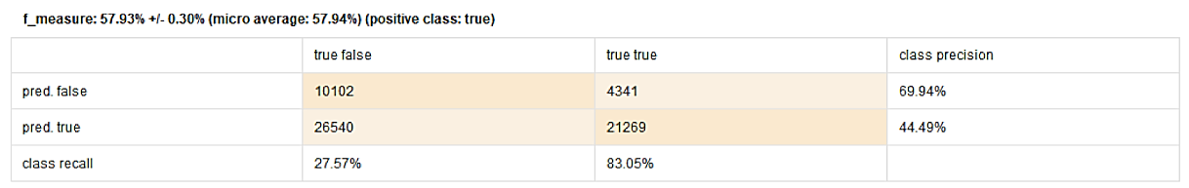

**Figure 14:** Performance Vector of baseline model (benchmark).

1. Feature Selection

Feature selection is imperative for the following reasons: (1) to produce simplistic models, that (2) run fast while, (3) avoiding the curse of dimensionality as much as possible, but simultaneously, (4) reduces the likelihood of overfitting. The weight of information gain of the attributes, and by experience, help to determine which attributes can be ignored. Attributes retained are {DEL_TARGET, DEP_TIME, DEP_TIME_BLK, DEST, DEST_CITY_NAME, DISTANCE, OP_UNIQUE_CARRIER, ORIGIN, ORIGIN_CITY_NAME, ORIGIN_STATE_ABR}. **However,** **DEP_TIME and DEP_TIME_BLK, as explained in *Section 5, part g*, where removed since these variables were creating a bias.**

1. Feature Engineering

There was a need to create a binary attribute, labeled DEL_TARGET, in order to run our classification models. The dataset did provide this information, but only for a time the flight was delayed beyond 15 minutes. However, our group wanted to capture lateness from the point of scheduled departure, therefore manually adding this attribute and set this to our target variable. Additionally, our group used one-hot encoding, focusing on the attributes of DEST, OP_UNIQUE_CARRIER, and ORIGIN, via the “Nominal to Numerical” operator to boost prediction capabilities.

1. Parameter Optimization

At least one method of optimization may involve tweaking certain features (e.g. pruning, number of trees) within operators but also doubling the sample size (i.e. 20%, instead of 10%) or sampling the sample data, in an effort to increase speed and efficiency. To quickly process adjustments in our model, one method our team implement was 3, instead of 5-fold, cross-validation and various process breaks.

1. Ensembles

Our group experimented with many ensemble operators, yielding mixed results:

* *Vote* – When combining the “Vote” operator with Gradient Boosted Trees and Random Forest, it yielded good results, but runtime increased substantially unless running on a computer with better processing power.
* *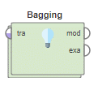Bagging* – Used with Gradient Boosted Trees. Result was a recall close to 30%, therefore making this a poor choice, with increased runtime.
* *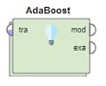AdaBoost –* This operator was used in conjunction with the “Vote” operator, (6) Gradient Boosted Trees and tested with Deep Learning, embedded within a 5-fold Cross Validation. When used collectively, performance improved to near 77% recall, explored further in Section 7, part c.

1. Initial Evaluations (Baseline Model with Improvements)

Due to our dataset containing both numerical, datetime, and nominal attributes, our team decided to run the “Compare Models” operator after using the “Collect” operator to gather multiple models in testing the performance of various classification models via 3-fold cross-validation, to handle the data types of our attributes. We decided to use the cross-validation as opposed to splitting our training data to test by a ratio of 70:30 (default proportions) because k-folds cross-validation provides a more “reliable estimate of the generalization error.”

We chose accuracy, precision, recall, and f-measure as the criterion in the “Performance” operator. After running analysis, the 3 top-performing models were:

* 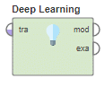Deep Learning – An H2O multi-layer feed-forward artificial neural network that is trained with stochastic gradient descent using back-propagation. (RapidMiner)
* 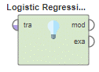Logistic Regression – A type of regression analysis used for predicting the outcome of a categorical criterion variable based on one or more predictor variables. (RapidMiner)
* 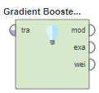Gradient Boosted Trees – An H2O ensemble of either regression or classification tree models. Both are forward-learning ensemble methods that obtain predictive results through gradually improved estimations. (RapidMiner)

|  |  |  |  |  |
| --- | --- | --- | --- | --- |
| **Model Type** | **Accuracy** | **Precision** | **Recall** | **f-measure** |
| Deep Learning | 0.615 | 0.518 | 0.752 | 0.612 |
| Logistic Regression | 0.666 | 0.616 | 0.470 | 0.533 |
| Gradient Boosted Trees | 0.631 | 0.533 | 0.745 | **0.621** |

With the 3-fold cross-validation, our team will decide to proceed with Gradient Boosted Trees, as this model consistently yields the highest initial f-measure (0.621 or 62.1%). However, Deep Learning also performed quite well in the model selection process as 2nd place with a f-measure of 0.621. *Figs. 15* and *16* display the RapidMiner algorithm results and process respectively.

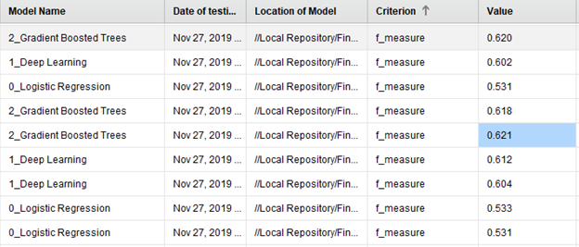

**Figure 15:** Performance Vector results of model algorithms.

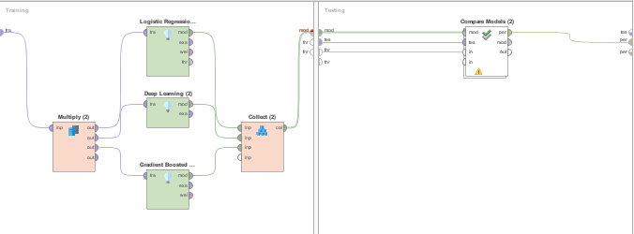

**Figure 16:** 3-fold cross-validation of improved baseline model.

**7.0 Model Modifications and Improvements**

Model modifications were done to the baseline model, in an effort to improve performance and to test the effect of varying parameters on operators:

* 1. Via Baseline + Filtering Missing Values (Departure Time Military)

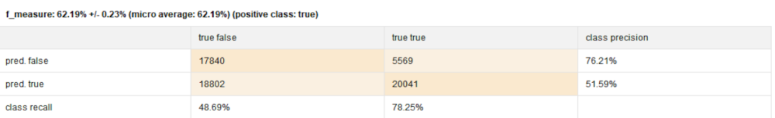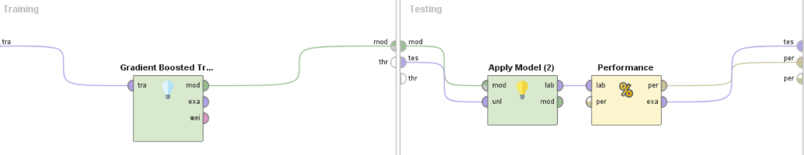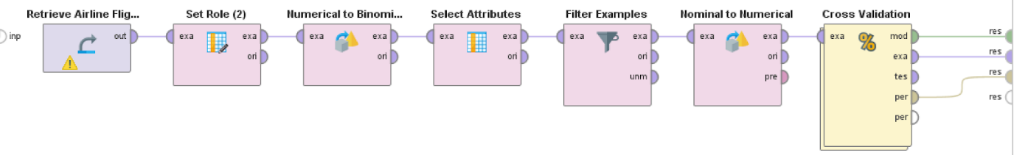The Filter Examples operator was added with DEP_TIME_MILITARY was removed, yielding a substantial improvement with our recall reaching 78.25% *[Fig. 17]*.

**Figure 17:** (Top to Bottom) Modified model, Cross-validation operator, performance vector.

1. Via Baseline + Filtering Missing Values + Incorporating Distance as an Attribute

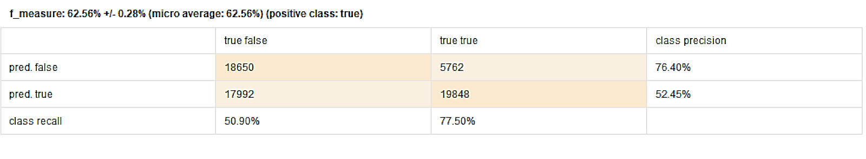When the baseline was adjusted to filter missing values, additionally incorporating distance as an attribute, the model provided the following results:

**Figure 18:** Performance vector for baseline w. filtered missing values and distance as attribute.

1. Via Baseline + Filter MV + Distance + One-Hot Encoding on Day-of-Week

Parts a and b were kept, plus the addition of one-hot encoding using the days of the week. Because the days of the week were numerical, they had to be converted from numerical to polynominal back to numerical, for RapidMiner to correctly identify the day *{Fig. 19].*

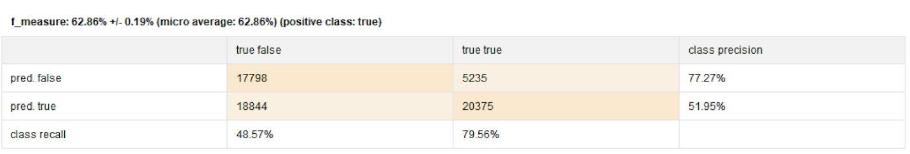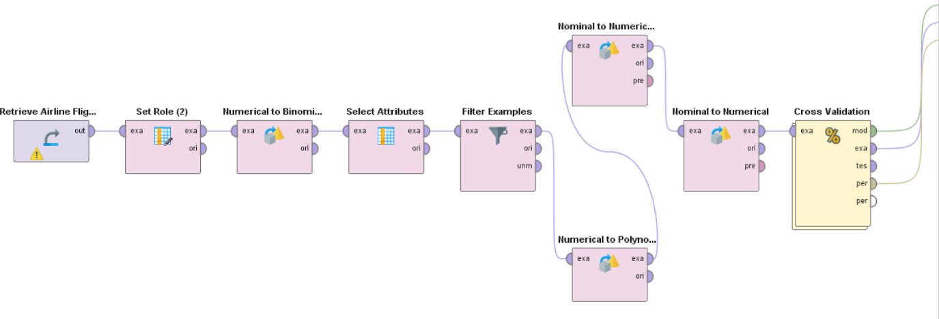

**Figure 19:** (Top to Bottom) Model process for best model, resulting performance vector.

1. Best of the Best

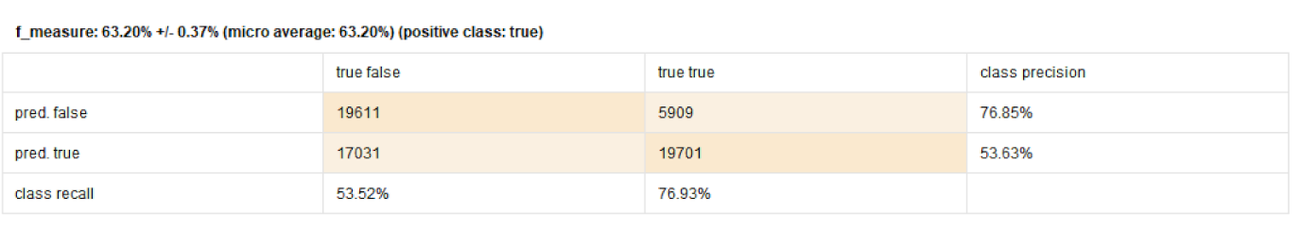Our group’s best model is one with an optimized depth of trees and cross validation folds, where gradient boosted trees (GBT) were optimized to 20 trees and the cross-validation increased 10-fold. This resulted in an overall approx. 10% increase in the performance of our model. from and initial F1 score of ~57% to an F1 score nearing 63% *[Fig. 20]*.

**Figure 20:** Performance vector of our group’s best model.

1. Via Baseline + AdaBoost (with Vote of (6) GBT)

The most complex of our model iterations involves imbedding an AdaBoost operator within the training side of the 5-fold cross-validation, furthered with a Vote operator, which contains six Gradient Boosted Trees (GBT) varying in number of trees from 10 to 200, and tree depth upwards of 100. It was the hope that the Vote operator would average the best-of-the-best scenario results, and that the AdaBoost would boost the performance of the best-of-the-best *[Fig. 21].*

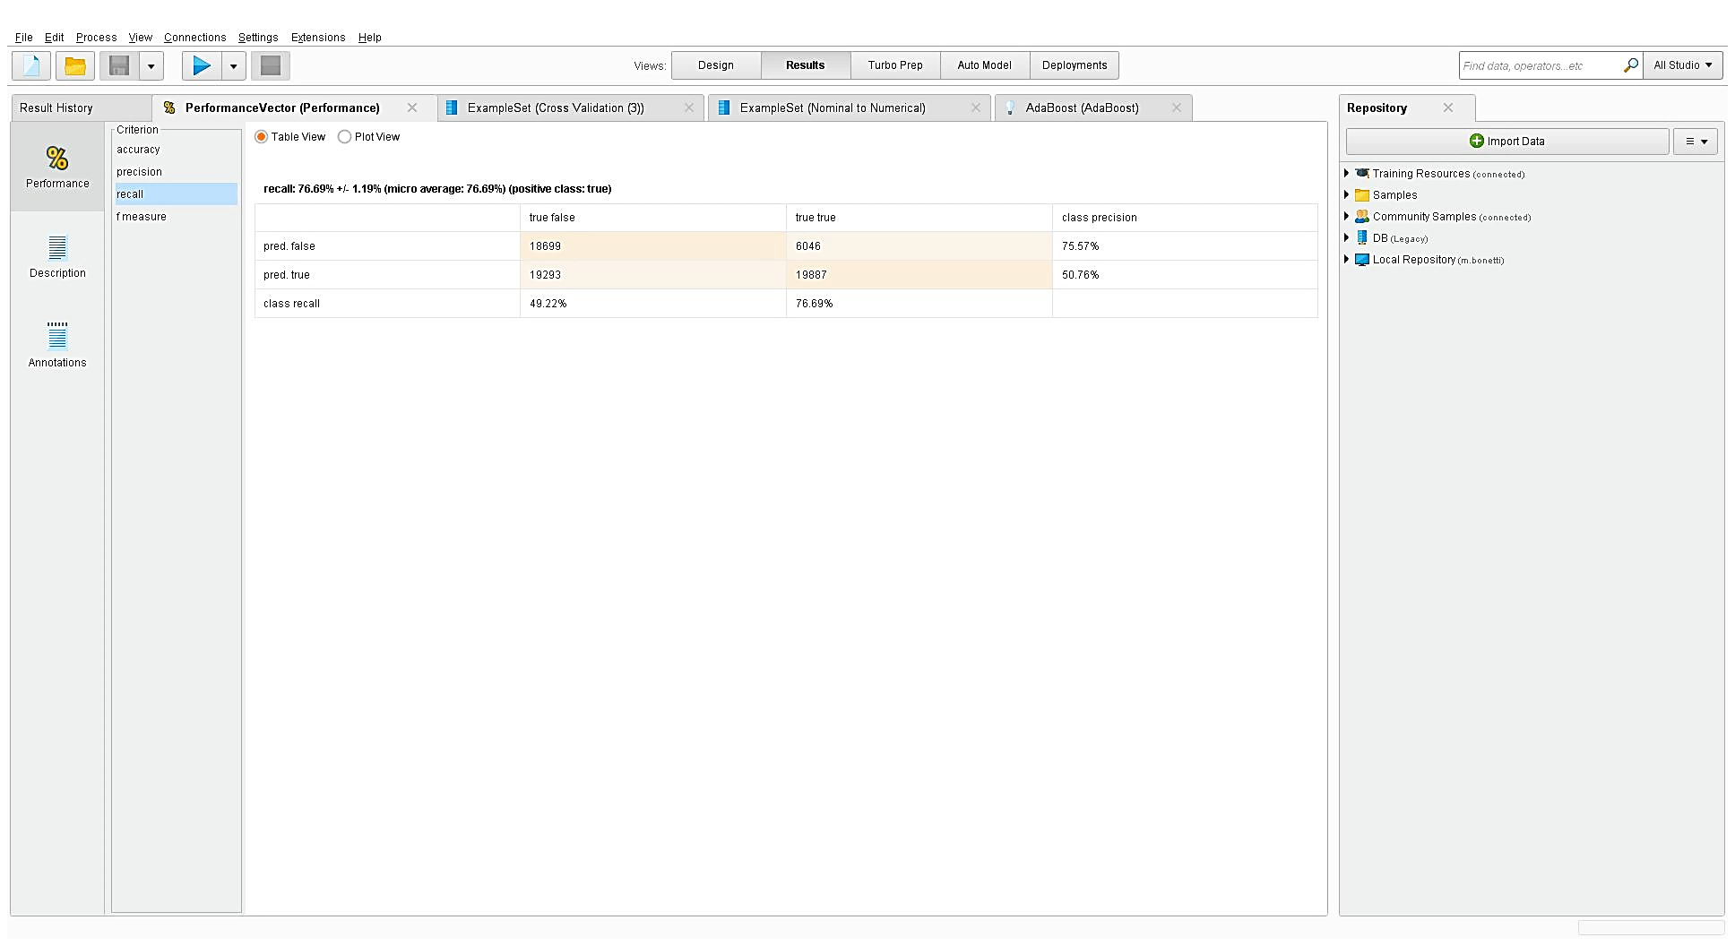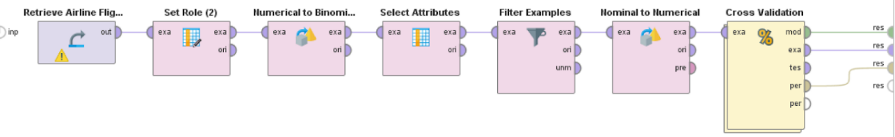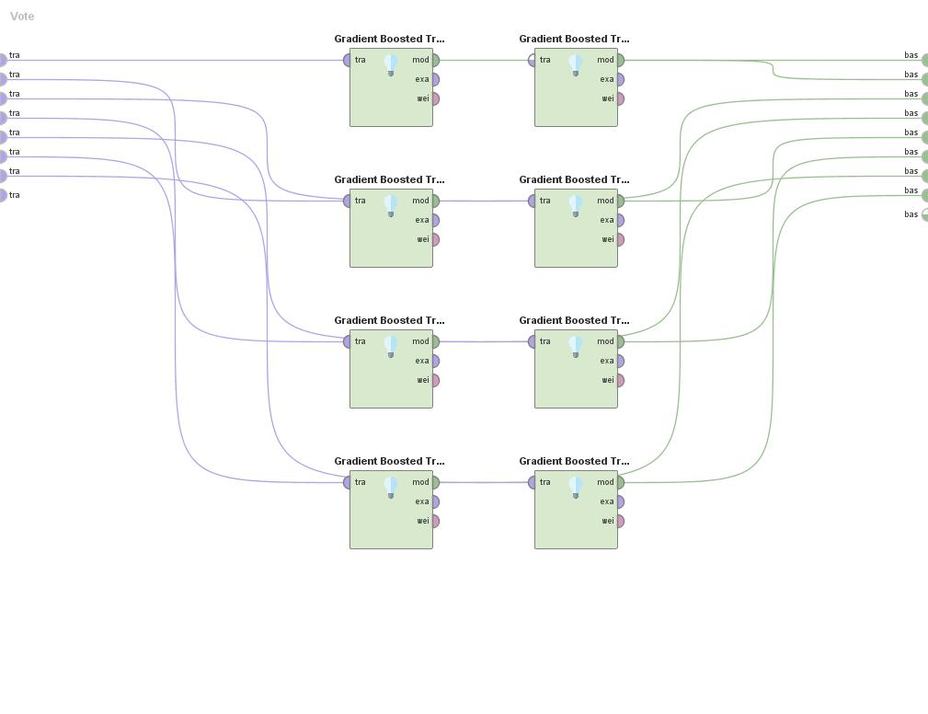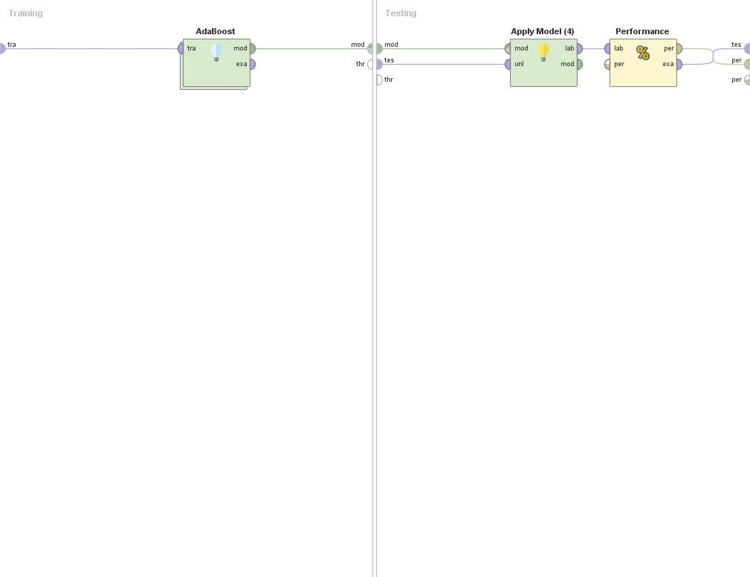

**Figure 21:** (Top to Bottom) Process using AdaBoost with Vote, The Vote Operator (with 6 Gradient Boosted Trees, Performance Vector.

Phase 3 Results & Business Strategy

**8.0 Results and Observations**

Our group’s best result was a predictive model with a near 77% recall and a 63% F1 score, a roughly 11% improvement from our baseline model. What our team has noticed was the inherit difficulty in finding a “Goldilocks” scenario, where the model can produce a high recall *and* high f-measure. Essentially, as our f-measure increased, recall decreased, and vice versa. Analogous to Occam’s Razor, we similarly discovered that a simpler model was better performing, by far. Increasing the number of modifications, adjustments and experimentations decreased our performance. Although, selecting and deselecting certain attributes did trigger significant fluctuations in our performance.

**9.0 Solving the Business Problem**

Based on the results of the model we created, and insights we considered from our tasks, we have developed several strategies by which an airline carrier and / or airport handling domestic flights within the United States, may use our information to better their airline services. Our recommendations would also be a way to bolster customer satisfaction, as well as other front-end services.

1. Procedure (Formulating the Business Strategy)

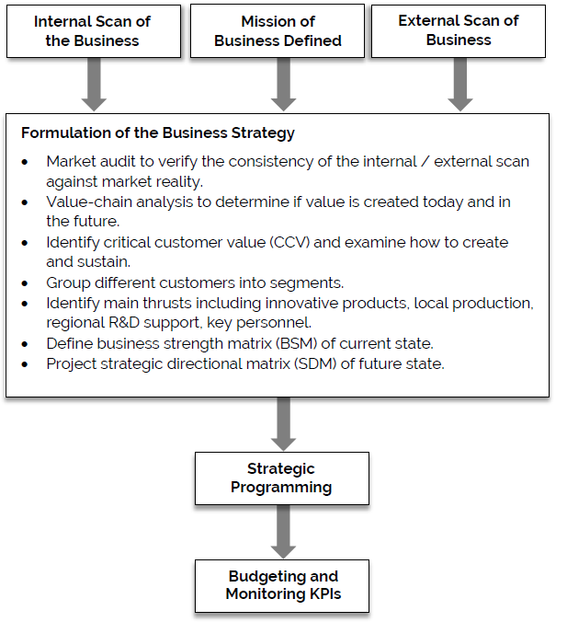Formulating a successfully business strategy involves the integration and execution of several interlinked actions:

**Figure 22:** Formulating a Business Strategy, from “Business Growth Strategies for Asia Pacific” (Chien, Shih, Chu)

*i. Market audit to verify consistency*

To market audit, the internal scan and external scans must be verified for consistency against the market reality. Internal scans of the business involve:

1. Assessing an airline carrier’s competitive position and,

2. Identifying that carrier’s internal factors to improve their competitiveness.

This is compared against external scans that focus on:

1. Overall assessment of industry attractiveness,

2. Identify external factors contributing to industry attractiveness,

3. Overall assessment of competitors’ strengths and weaknesses,

4. Identify external factors affecting the carrier’s competitiveness.

1. *Value-Chain Analysis*

A data model that can accurately predicts as many late flights as possible, will greatly improve an airline company’s value and competitive advantage against other airlines. The entire data modeling process would be classified under two general sections in Michael E. Porter’s Value-Chain Analysis (1) the Technology section of support activities and (2) Inbound Logistics of primary activities. An accurate data model will sort inbound logistics and streamline the Operations portion of the business. Furthermore, innovations in technology should not be seen as a Red Ocean trap (Kim & Mauborgne, 2015) but rather to complement the firm’s infrastructure, provide a better quality of service to the customer, which will ideally lead to higher profitable margins.

**Figure 23:** Value-Chain Analysis, from Michael E. Porter’s “Competitive Advantage: Creating and Sustaining Superior Performance”

1. *Identifying Main Thrusts*

This segment of formulating the business strategy relies on research and development (R&D), innovation and the right personnel. The entire project as a whole is merely a first-level expandatory process, that accounts for only a fraction or a much larger operation, beyond the scope of *CIS 9660 – Data Mining for Business Analytics.* The right personnel need to be in place and ready to initiate a more hands-on approach, to analyze and investigate the reasonings for airline departure delays. Capturing more customers within the default pool provides an invaluable competitive advantage to airline companies and airports alike*.*

1. *Moving Forward*

Airline carriers and/or airport management will have to perform strategic programming and budgeting / monitoring for key performance indicators (KPI) in order to fully take advantage of a strong business strategy. This may involve obtaining feedback from airline customers, finding ways to improve processes and budgeting consolidations beyond the scope of *CIS 9660 – Data Mining for Business Analytics*.

1. Description

Airport and airline carrier management would use adjust flights in the most congested locations, tailored to the most traveled times of day and time, to effectively relieve congestion on the tarmac and streamline gate turnaround of an aircraft.

1. Insights & Recommendations

The figures *[Figs. 24 – 30]* on the following section highlight our group’s insights from our airline delay project. It is particularly interesting that the duration of a flight, which day of the week, airport of origin, and airline carrier all provide a telltale story as to where delays originate, short of weather and mechanical issues, and how to best address them. All time blocks are within the hour except from 12a to 6a and only airports with 100+ flights were included.

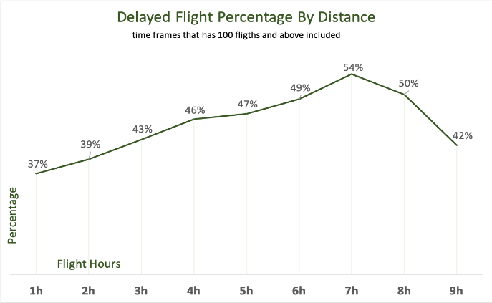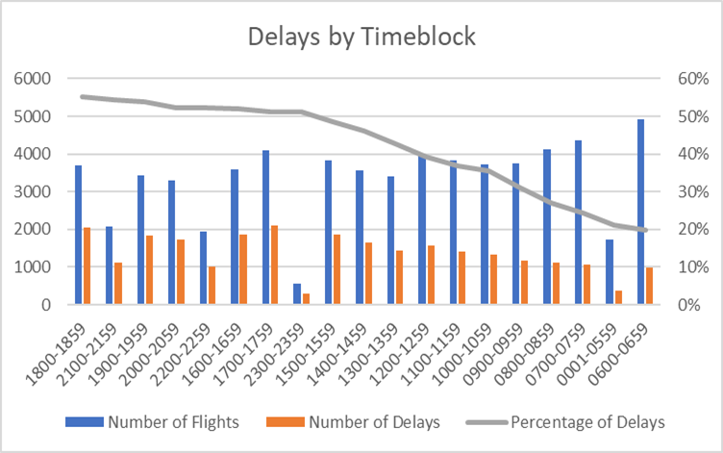

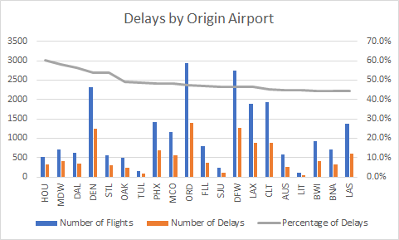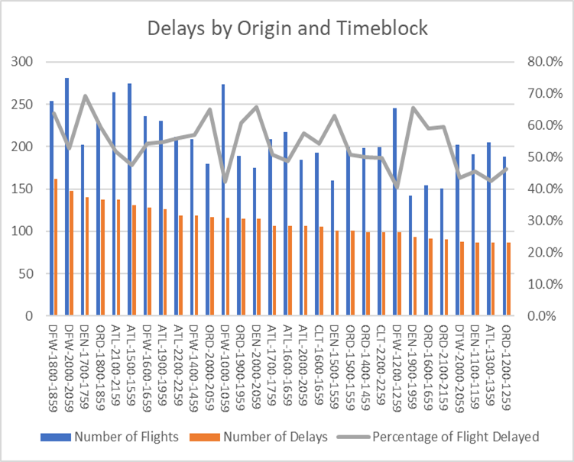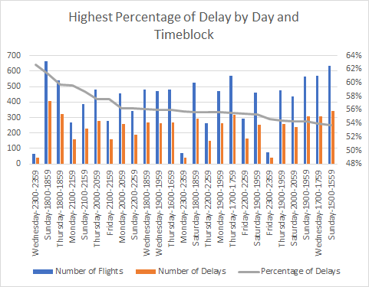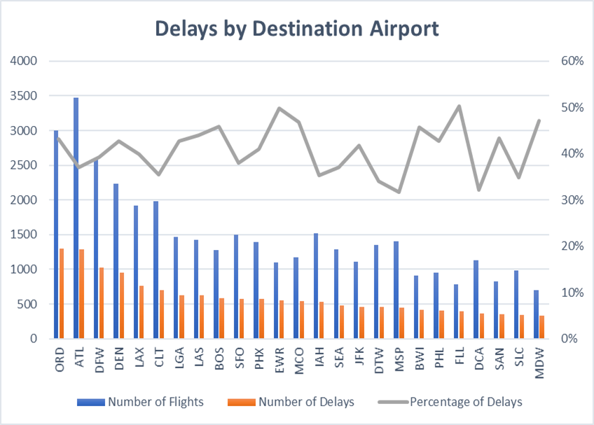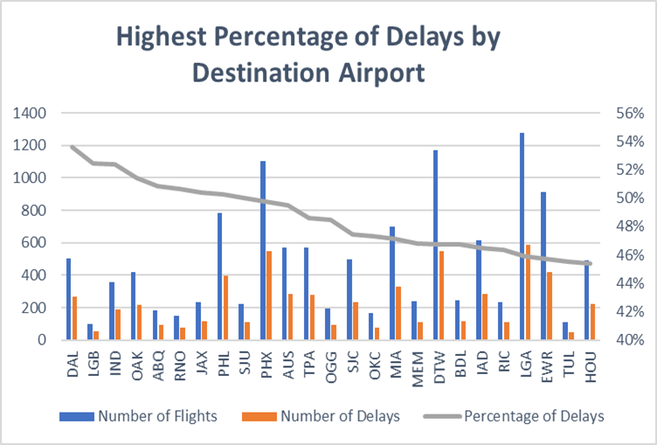

**Figures 24–30:** (In Order, top-bottom pg. 19, left-right pg. 20): Delayed Flight % per distance; Delays per Timeblock; Delays per Destination; Highest % Delays per Destination Airport; Delays per Day & Timeblock; Delays per Origin & Timeblock; Delays per Origin Airport.

1. Closing Thoughts

Our group knew that it would be near impossible to predict with 100% certainty if a flight were to be delayed or not. Airline companies have teams of weather forecasters constantly monitoring the weather 24 hours a day, 7 days a week. We specifically chose an off-month to reveal what may cause a flight to be delayed, *other* than mechanical issues or inclement weather. Our group would have loved to explore a comparison between different months of the year, however due to time constraints, this was unachievable. What we generally noticed was that our highest model performance metric is nearly in line with annual flight delays of the domestic US flights: at about 20%, with an on-time performance of 80%. In the end, any prediction model for airline flight delay would be a peak into a grander, more complex problem that would be addressed by the information technology teams of airport management and airline carriers working in unison.

References

RapidMiner Documentation website, *www.rapidminer.com*

Chien, W., Shih, S., & Chu, P.-Y. (2005). *Business Growth Strategies for Asia Pacific.*

Singapore & London, U.K.: John Wiley & Sons (Asia) Pte Ltd.

Kim, W. C., & Mauborgne, R. (2015, March). Red Ocean Traps. *Harvard Business*

*Review*, pp. 1-12

Porter, M. E. (1985). *Competitive Advantage: Creating and Sustaining Superior*

*Performance.* New York: Free Press.

Appendix A – Data Dictionary

|  |  |
| --- | --- |
| **Attribute** | **Description** |
| DEL_TARGET | Target Variable. 1=flight delayed beyond scheduled time, 0=flight departed on-time or early. |
| DEP_TIME | Actual Departure Time (local time: hhmm) |
| DEP_TIME_MILITARY | Converts DEP_TIME as a time value rather than integer. |
| DEP_TIME_BLK | CRS Departure Time Block, Hourly Intervals |
| DEST | Destination Airport |
| DEST_CITY_NAME | Destination Airport, City Name |
| DISTANCE | Distance between airports (miles) |
| OP_UNIQUE_CARRIER | Unique Carrier Code. When the same code has been used by multiple carriers, a numeric suffix is used for earlier users, for example, PA, PA (1), PA (2). Use this field for analysis across a range of years. |
| ORIGIN | Origin Airport |
| ORIGIN_CITY_NAME | Origin Airport, City Name |
| ORIGIN_STATE_ABR | Origin Airport, State Code |
| TOTAL_ADD_GTIME | Total ground time away from agate for gate return or cancelled flight |
| LONGEST_ADD_TIME | Longest time away from gate for gate return or cancelled flight |
| FIRST_DEP_TIME | First gate departure time at origin airport |
| CANCELLATION_CODE | Specified the reason for cancellation |

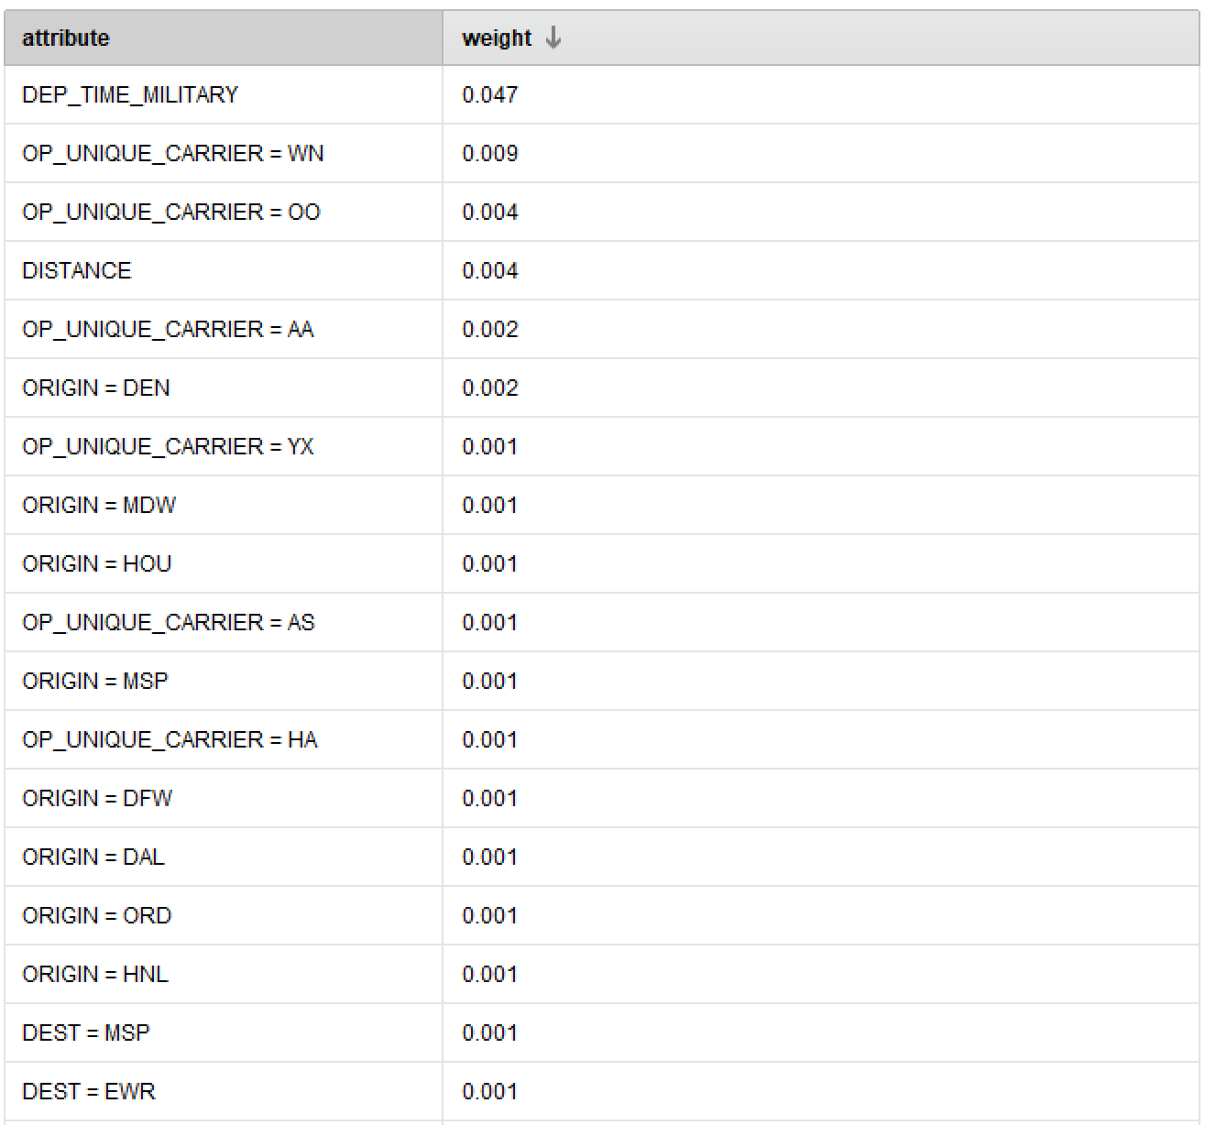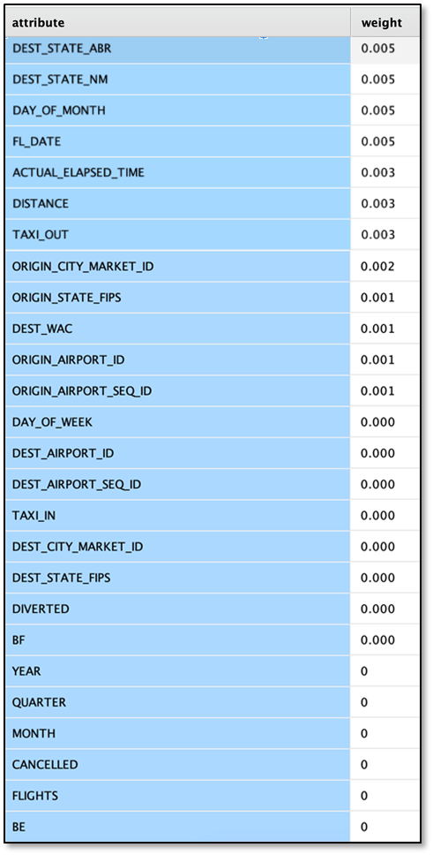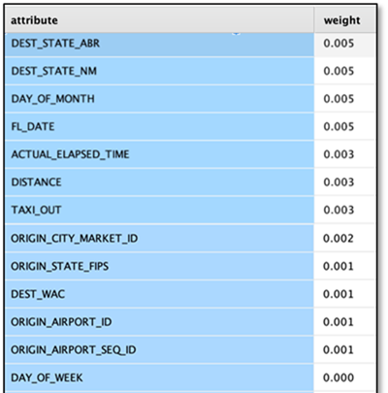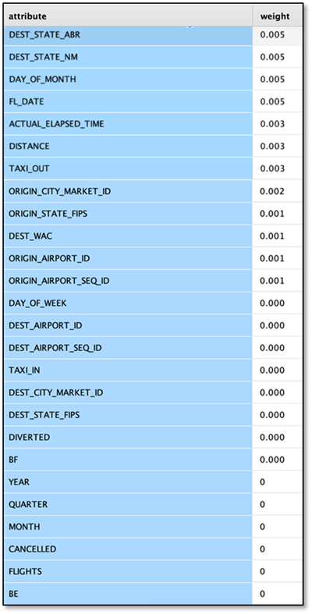Appendix B – Weights by Information Gain

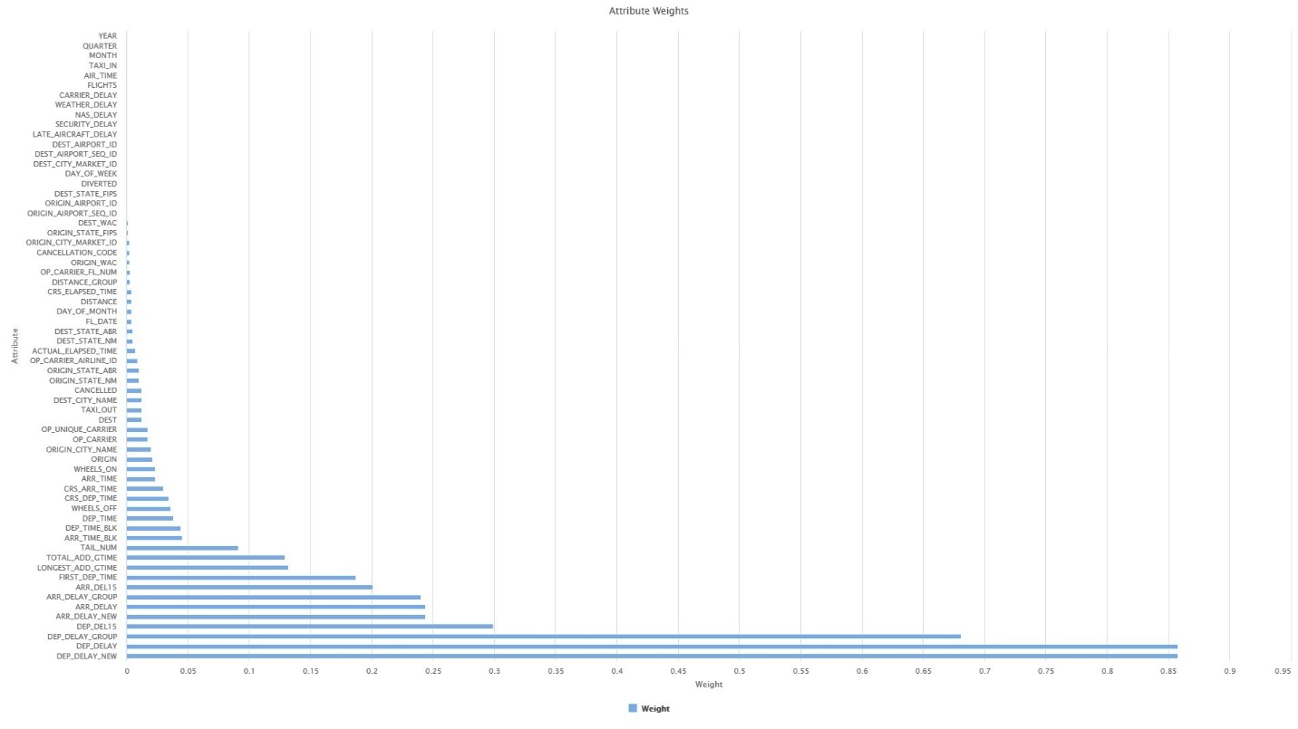

**Figure A-1:** RapidMiner horizontal bar graph of attribute weights by information gain.

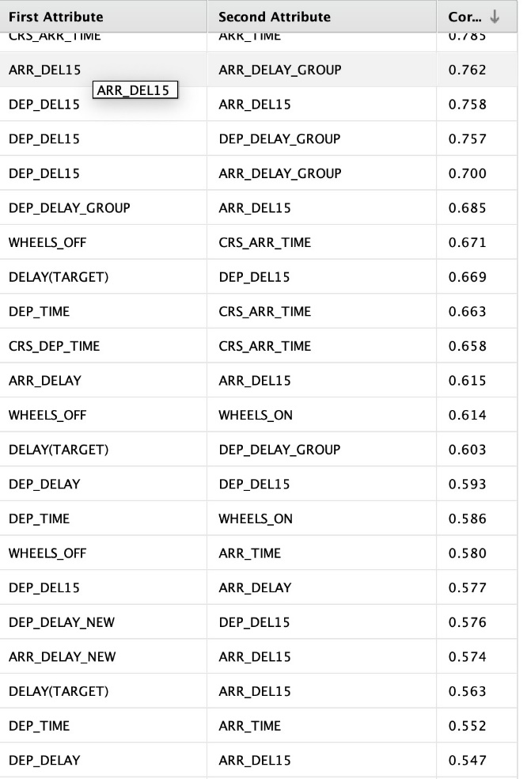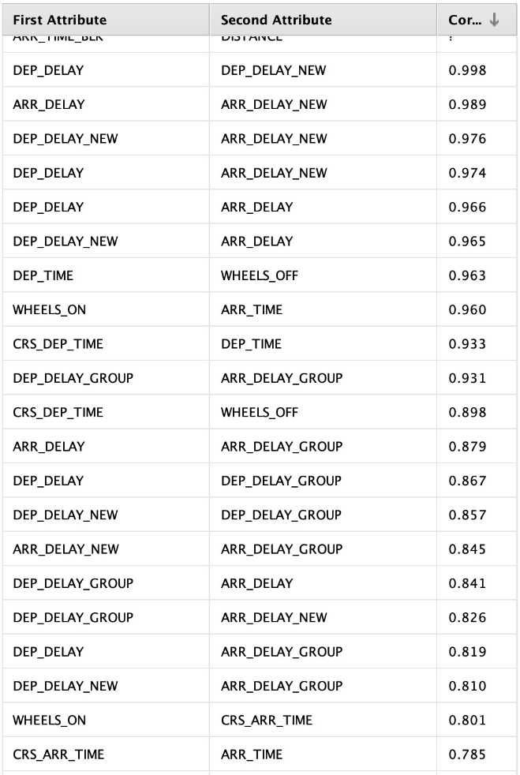Appendix C – Correlation of Attributes

This page has been intentionally left blank.